Rising Waters – Flood Prediction System

Abstract
This project develops a machine learning-based flood prediction system using historical weather data to predict flood risk and provide early warnings.

Introduction

Floods are increasing due to climate change, urbanization, and poor drainage. Early prediction helps reduce damage and save lives.

Problem Statement

Develop an accurate flood prediction model and deploy it as a Flask web application.

Objectives

• Analyze flood dataset
• Preprocess data
• Train Decision Tree, Random Forest, KNN, and XGBoost
• Compare models
• Deploy best model using Flask.

Dataset
Dataset: Kaggle Rainfall/Flood Dataset (flood dataset.xlsx).

Methodology

1. Data Collection
2. Data Analysis
3. Data Preprocessing
4. Model Building
5. Deployment using Flask

Data Analysis

Performed dataset exploration, univariate analysis, multivariate analysis, correlation heatmap, descriptive statistics.

Data Preprocessing

Handled missing values, removed outliers using IQR, encoded categorical variables if present, split train/test data, applied StandardScaler.

Algorithms

Decision Tree:

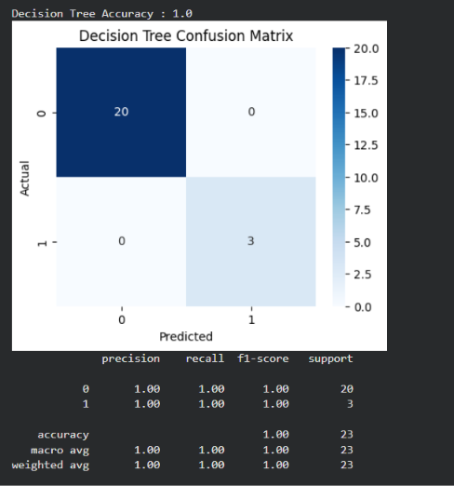

Random Forest:

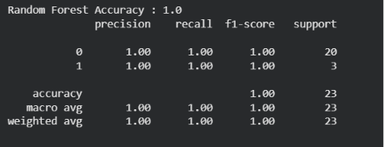

K-Nearest Neighbors:

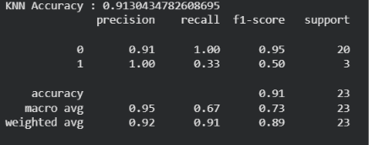

XGBoost:

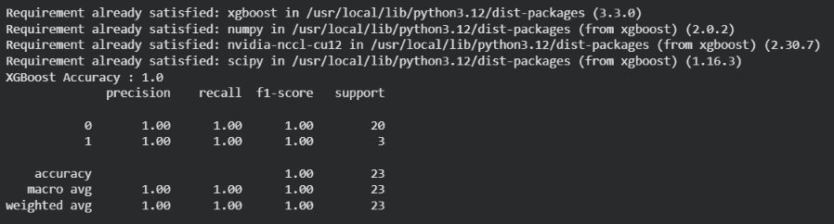

Model Evaluation

Compared models using Accuracy, Confusion Matrix, Precision, Recall and F1-score. Selected the best-performing model and saved it as flood_model.pkl.
Screenshot:

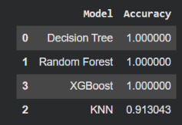

Application Development

Built a Flask application with home, prediction, flood alert and safe result pages using HTML, CSS and JavaScript.

Results

The deployed application accepts weather parameters, scales them using StandardScaler, predicts flood risk using the trained model and displays the appropriate result.
Screenshots:

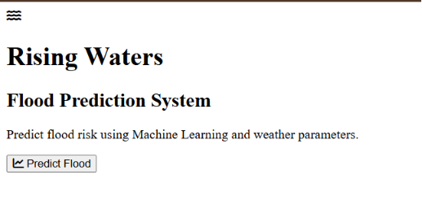

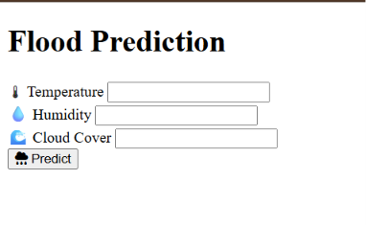
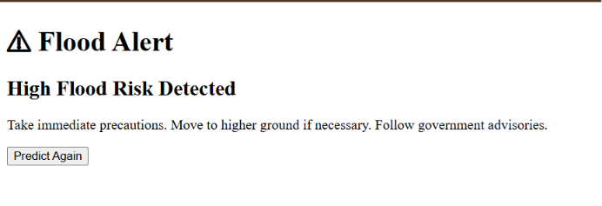

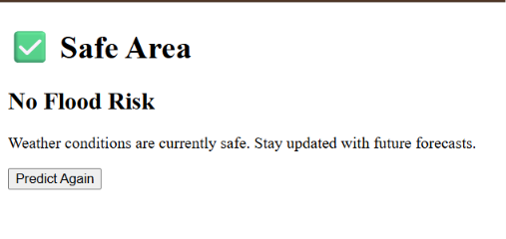

Conclusion

The project demonstrates how machine learning and Flask can be combined to support flood risk prediction and disaster preparedness.

Future Scope

Integrate real-time weather APIs, GIS mapping, IoT sensors, SMS alerts and cloud deployment.

References

1. Kaggle Flood Dataset
2. Scikit-learn Documentation
3. XGBoost Documentation
4. Flask Documentation

Project Workflow

Epic 1: Data Collection
Epic 2: Data Analysis
Epic 3: Data Preprocessing
Epic 4: Model Building
Epic 5: Flask Deployment

Technologies Used

Python,
Google Colab,Pandas,
NumPy,
Matplotlib,Seaborn,
Scikit-learn, XGBoost,
Flask, HTML,CSS,
JavaScript,Joblib.

Presented by,
Geethika Errabilli
23331A4215
MVGR College of Eng..

